**NAME : AWANTIKA KHATRI**

**STUDENT ID : BIT-24S-015**

**DEPARTMENT : INFORMATION TECHNOLOGY**

**SUBJECT : ARTIFICIAL TECHNOLOGY**

**LAB:1**

**TASK:1**

**NUMERIC TYPES**

**INTEGAER(INT)**

num1 = 42

num2 = -99

float_num = float(num2)

print(float_num)

**OUTPUT**

-99.0

**FLOATING-POINT(Float)**

pi = 3.14

negative_float = -2.5

int_pi = int(negative_float)

print(int_pi)

**OUTPUT**

-2

**COMPLEX(Complx)**

c1 = 2 + 3j

c2 = 4 - 2j

c_real = c1.real

print(c_real)

**OUTPUT**

2.0

**TASK:2**

**SEQUENCE TYPES**

**STRING(str):**

text1 = "artifical intelligence"

text2 = 'Learning is fun'

char_list = list(text1)

print(char_list)

**OUTPUT**

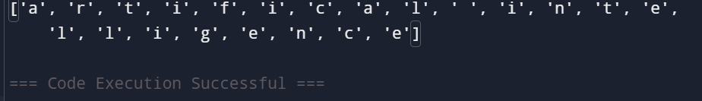

**LIST(list):**

numbers = [1, 2, 3, 4]

mixed_list = [1, "hello", 3.5]

tuple_numbers = tuple(mixed_list)

print(tuple_numbers)

**output**

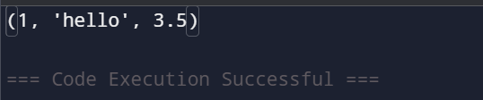

**TUPLE(tuple):**

coordinates = (10, 20)

values = (1, 2, 3, 4)

list_values = list(values)

print(list_values)

**output**

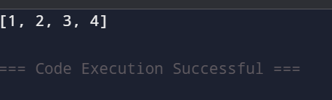

**RANGE(range):**

r1 = range(5)

r2 = range(1, 10, 2)

range_list = list(r1)

print(range_list)

**output**

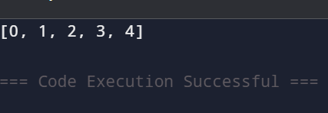

**TASK:3**

**SETS TYPES**

**SET(sets)**

unique_numbers = {1, 2, 3, 3}

char_set = {'a', 'b', 'c'}

set_list = list(unique_numbers)

print(set_list)

**output**

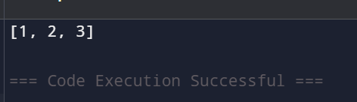

**FROZEN SETS(frozensets)**

frozen = frozenset([1, 2, 3])

frozen_chars = frozenset('abc')

frozen_list = list(frozen)

print(frozen_list)

**Output**

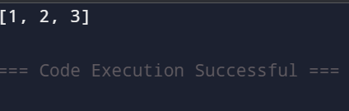

**TASK:4**

**MAPPING TYPE**

**DICTIONARY(dict)**

person = {"name": "Alice", "age": 25}

student = {"id": 101, "grade": "A"}

dict_keys = list(person.keys())

print(dict_keys)

**OUTPUT**

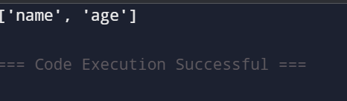

**TASK:5**

**BOOLEAN TYPE**

**BOOLEAN(bool)**

is_python_fun = True

is_raining = False

bool_num = bool(1)

print(bool_num)

**OUTPUT**

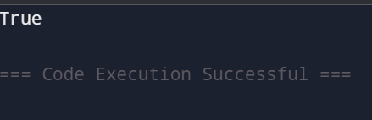

**LAB:4**

**TASK:1**

a = float(input("Enter first number: "))

b = float(input("Enter second number: "))

print("Sum:", a + b)

print("Difference:", a - b)

print("Product:", a * b)

print("Quotient:", a / b)

print("Remainder:", a % b)

**OUTPUT**

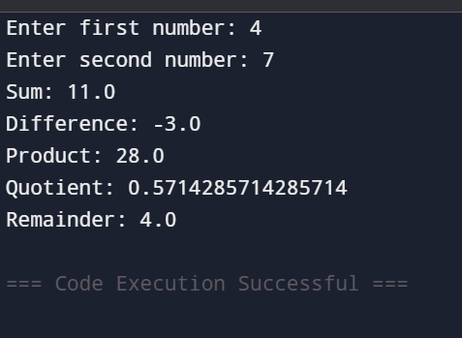

**TASK:2**

def arithmetic_operations(a, b):

return a + b, a - b, a * b, a / b

a = float(input("Enter first number: "))

b = float(input("Enter second number:"))

sum_, diff, prod, quot = arithmetic_operations(a, b)

print("Sum:", sum_)

print("Difference:", diff)

print("Product:", prod)

print("Quotient:", quot)

**OUTPUT**

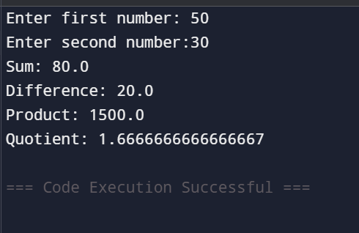

**TASK:3**

a = int(input("Enter the dividend: "))

b = int(input("Enter the divisor:"))

remainder = a % b

print("Remainder:", remainder)

**OUTPUT**

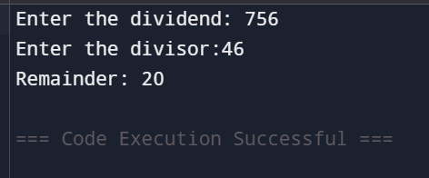

**TASK:4**

import math

radius = float(input("Enter the radius of the circle: "))

area = math.pi * radius ** 2

print("Area of the circle:", area)

**OUTPUT**

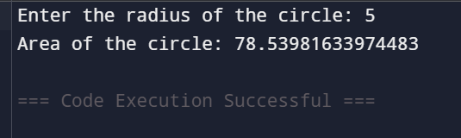

**TASK:5**

num = float(input("Enter a number: "))

square = num ** 2

cube = num ** 3

print("Square:", square)

print("Cube:", cube)

**OUTPUT**

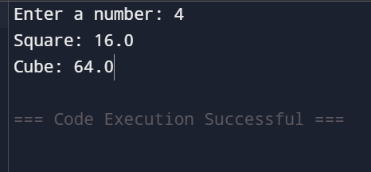

**TASK:6**

print("Select operation:")

print("1. Add")

print("2. Subtract")

print("3. Multiply")

print("4. Divide")

operation = input("Enter choice (1/2/3/4): ")

num1 = float(input("Enter first number: "))

num2 = float(input("Enter second number: "))

if operation == '1':

print("Result:", num1 + num2)

elif operation == '2':

print("Result:", num1 - num2)

elif operation == '3':

print("Result:", num1 * num2)

elif operation == '4':

if num2 != 0:

print("Result:", num1 / num2)

else:

print("Error: Cannot divide by zero")

else:

print("Invalid input")

**OUTPUT**

**ll**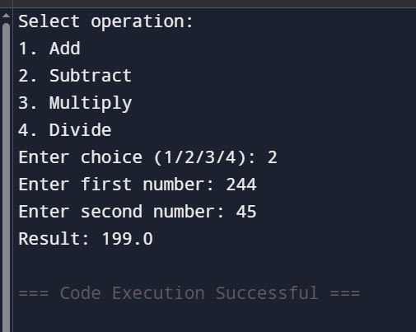

**LAB:5**

**TASK:1**

**BASIC TASK(Alternative version)**

def check_number(n):

if n > 0:

return "Positive"

elif n < 0:

return "Negative"

else:

return "Zero"

number = float(input("Enter a number: "))

result = check_number(number)

print(f"The number is {result}.")

**output**

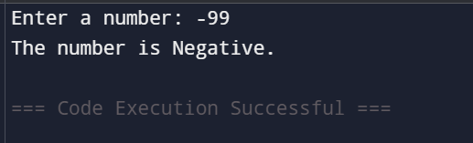

**TASK:2**

**INTERMEDIATE (Alternative version)**

num = int(input("Enter an integer: "))

if num % 2 == 0:

print("The number is even.")

else:

print("The number is odd.")

**OUTPUT**

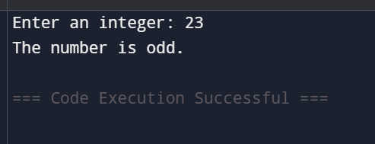

**TASK:3**

**ADVANCED (Classify student performance based on marks)**

marks = float(input("Enter your marks (0-100): "))

if marks > 80:

print("Excellent")

elif 60 <= marks <= 80:

print("Good")

else:

print("Needs Improvement")

**output**

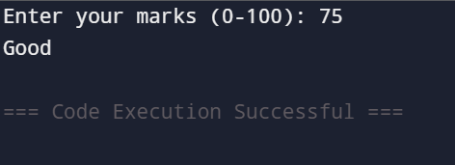

**LAB:6**

**TASK:1**

**BASIC TASK (Print the first 10 natural numbers using a for loop)**

for i in range(1, 11):

print(i)

**OUTPUT**

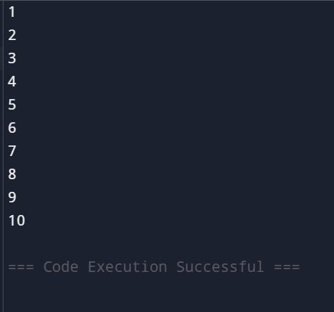

**TASK:2**

**Intermediate Task** (Print numbers from 10 down to 1 using a while loop)

i = 10

while i >= 1:

print(i)

i -= 1

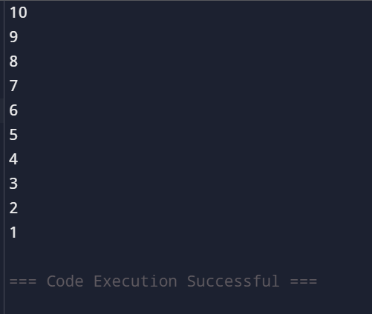

**TASK:3**

**Advanced Task (Count the number of vowels in a string using a for loop)**

text = input("Enter a string: ")

vowels = "aeiouAEIOU"

count = 0

for char in text:

if char in vowels:

count += 1

print(f"Number of vowels: {count}")

**OUTPUT**

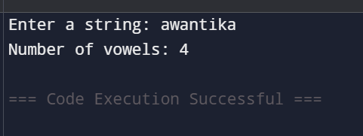

**TASK:4**

**Challenge Task (Print the Fibonacci series up to n terms using a while loop)**

n = int(input("Enter the number of terms: "))

a, b = 0, 1

count = 0

while count < n:

print(a)

a, b = b, a + b

count += 1

**output**

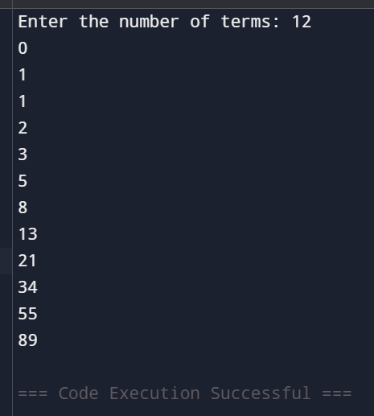

**Python loop task:**

**Task:1**

**Print numbers from 1 to 10 using a for loop**

for i in range(1, 11):

print(i)

**OUTPUT**



**TASK:2**

**Print all even numbers between 1 and 20 using a loop**

i = 2

while i <= 20:

print(i)

i += 2

**OUTPUT**

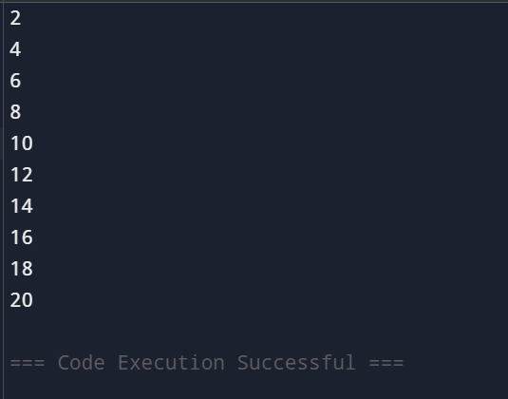

**TASK:3**

**Calculate the sum of numbers from 1 to 100 using a loop**

total = 0

for i in range(1, 101):

total += i

print("Sum from 1 to 100 is:", total)

**OUTPUT**

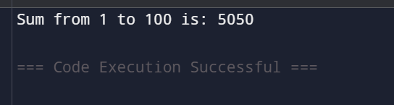

**TASK:4**

**Print the multiplication table of 5 using a loop**

num = 5

for i in range(1, 11):

print(f"{num} x {i} = {num * i}")

**OUTPUT**

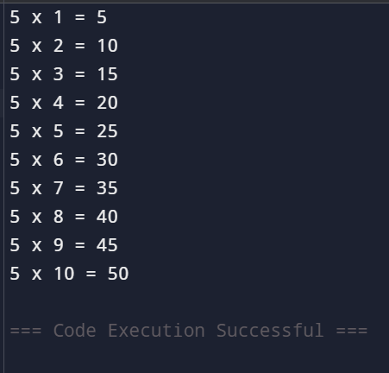

**TASK:5**

**Find the factorial of a given number using a** for **loop**

num = int(input("Enter a number: "))

factorial = 1

for i in range(1, num + 1):

factorial *= i

print(f"Factorial of {num} is {factorial}")

**OUTPUT**

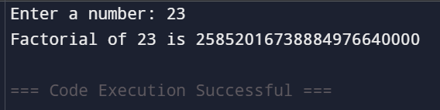

**TASK:6**

**Iterate over a list of fruits and print each item**

fruits = ["apple", "banana", "cherry", "mango", "orange"]

for fruit in fruits:

print(fruit)

**OUTPUT**

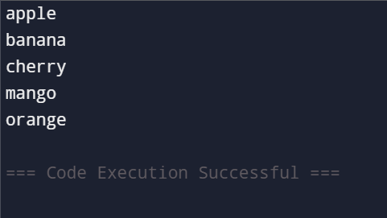

**TASK:7**

**Create a list of numbers and print only the odd numbers using a loop**

numbers = [1, 2, 3, 4, 5, 6, 7, 8, 9, 10]

for num in numbers:

if num % 2 != 0:

print(num)

**OUTPUT**

